WEEK 2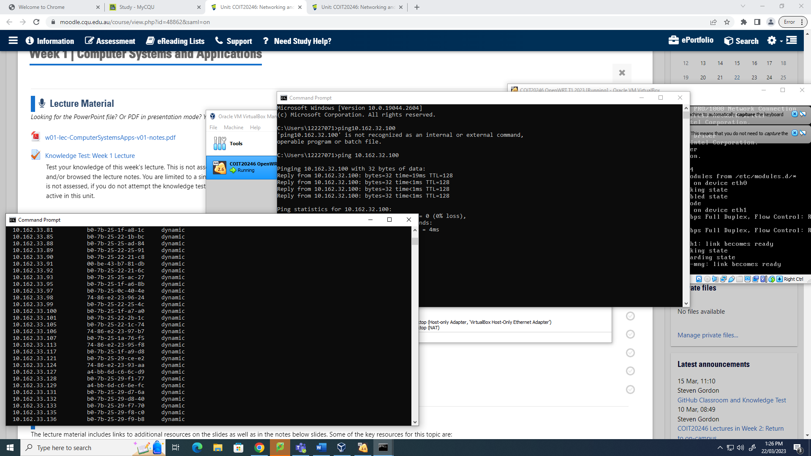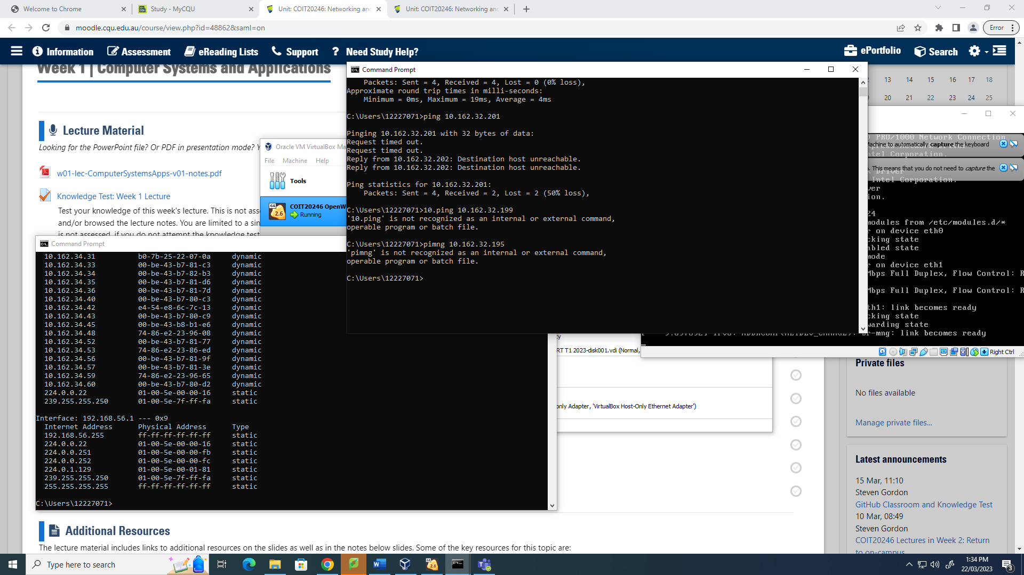

WEEK 3

